Communities Empowering Families for Success

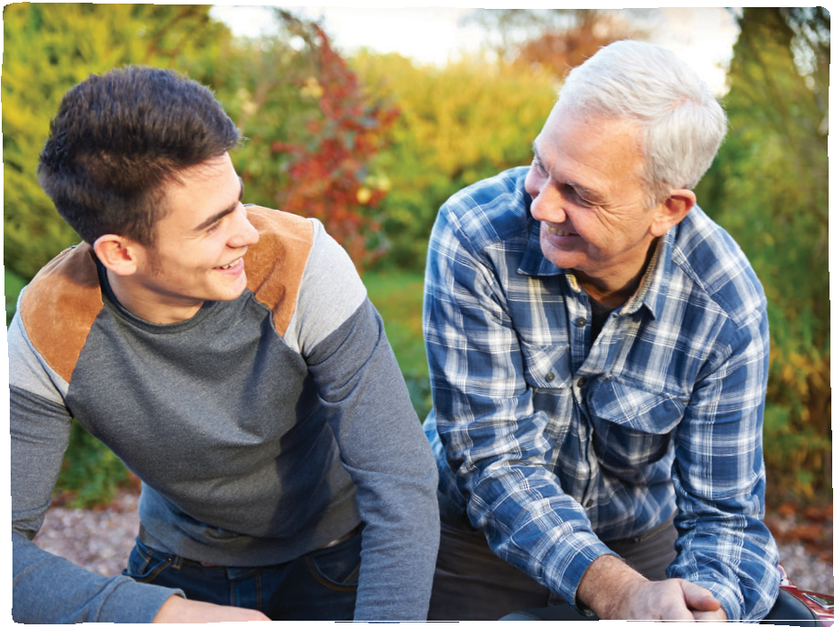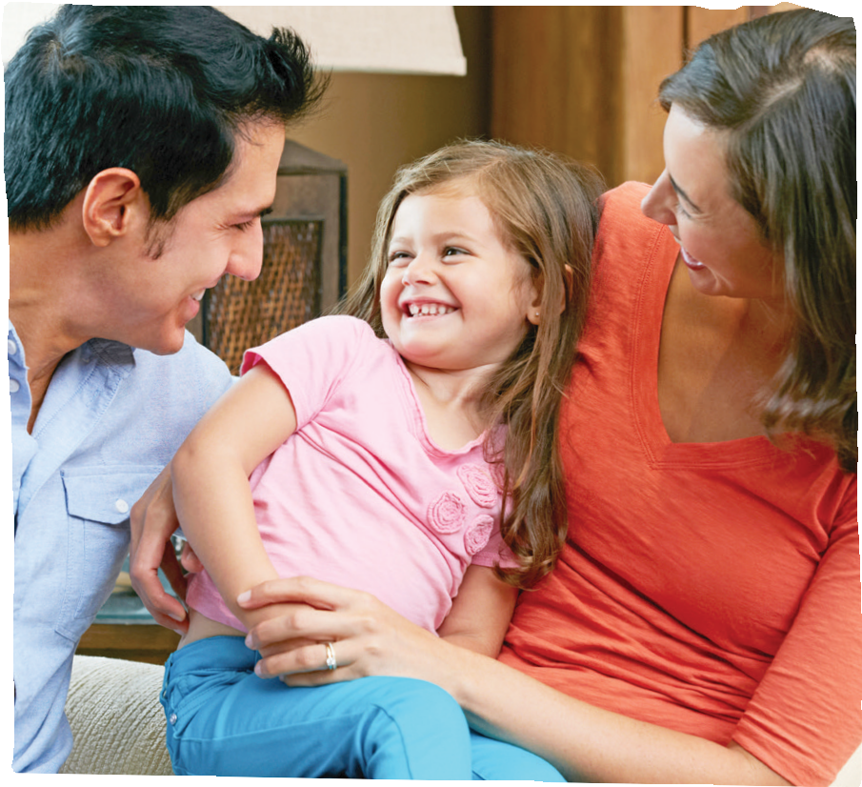Parents, come be encouraged!
Raising Highly Capable Kids™ is an exciting, interactive, practical tool for parents to engage and build community with other parents while raising healthier, more caring and responsible children.
In this 13-week course parents will engage with material centered on personal development and practical skills to improve their children’s social, educational and emotional abilities. Class topics include valuing and seeking support, encouraging responsibility in children, empowering their decision-making, improving empathy, friendship skills, resistance to negative peer pressure, and ability to resolve conflict.
If there’s anything you don’t need, it’s one more thing to do. Unless that one thing might make the other things a whole lot easier.

This parenting class is free!
- August 28
- September 4, 11, 18, 25
- October 2, 9, 16, 23, 30
- November 6, 13, 20
WHEN:
Classes start Aug 28, 2019
WHERE:
Name of Location and address

CONTACT:
© 2019 RezilientKidz
Name / phone Email

